For purposes of forecasting, the sales data has been separated in two sets, by distribution channel: Location=3021 (Denmark) and Location=3022 (Netherlands). Only the sales from a distribution channel in Europe have been used, that is, the units sold in the variable ActualSales_DC. The data has been aggregated (by summing) to the month level, so for each of the two distribution channels we have 42 months worth of data, from January 2014 to June 2017 (the data after June 2017 is incomplete and therefore excluded). These are the first 10 rows of the Denmark aggregated dataset:

Obs | MonthYear | TotalSales
1 | JAN2014 | 3,406
2 | FEB2014 | 13,577
3 | MAR2014 | 35,883
4 | APR2014 | 65,838
5 | MAY2014 | 37,477
6 | JUN2014 | 35,694
7 | JUL2014 | 20,761
8 | AUG2014 | 55,399
9 | SEP2014 | 23,994
10 | OCT2014 | 2,286

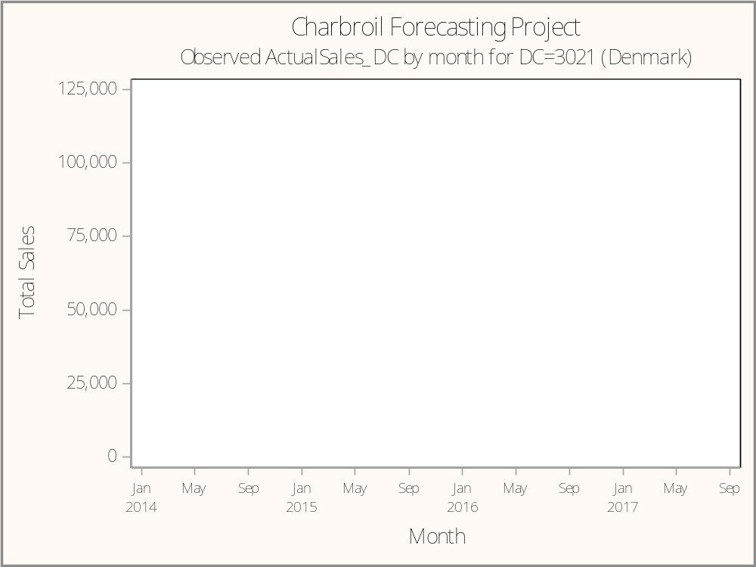

This time series exhibits clear seasonality (similar monthly pattern repeated over the years), and a slight upward trend. Therefore, we choose a forecasting model that can accomodate both trend and seasonality: Peter Winters' 3-parameter exponential-smoothing forecasting model. Because we see that the seasonal cycle appears to be amplified over the years, we choose the multiplicative version of Winters' model.

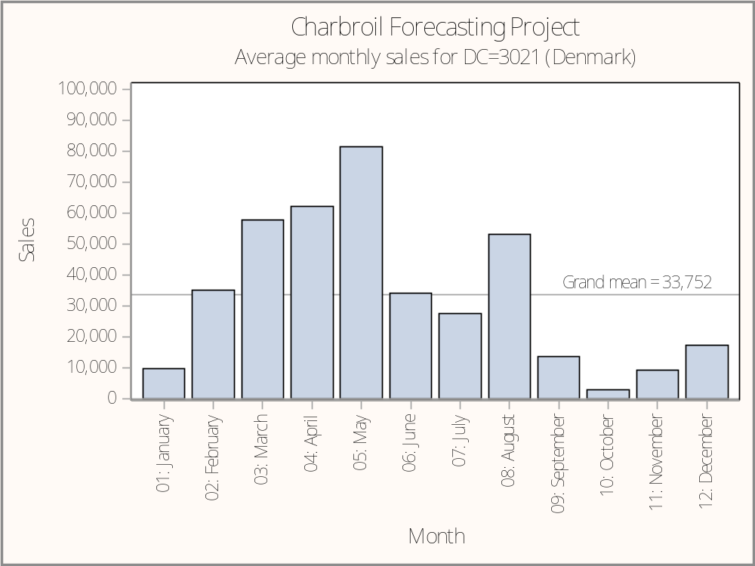

We can plot the average sales by month, and see that seasonality is a substantial source of variation in sales.

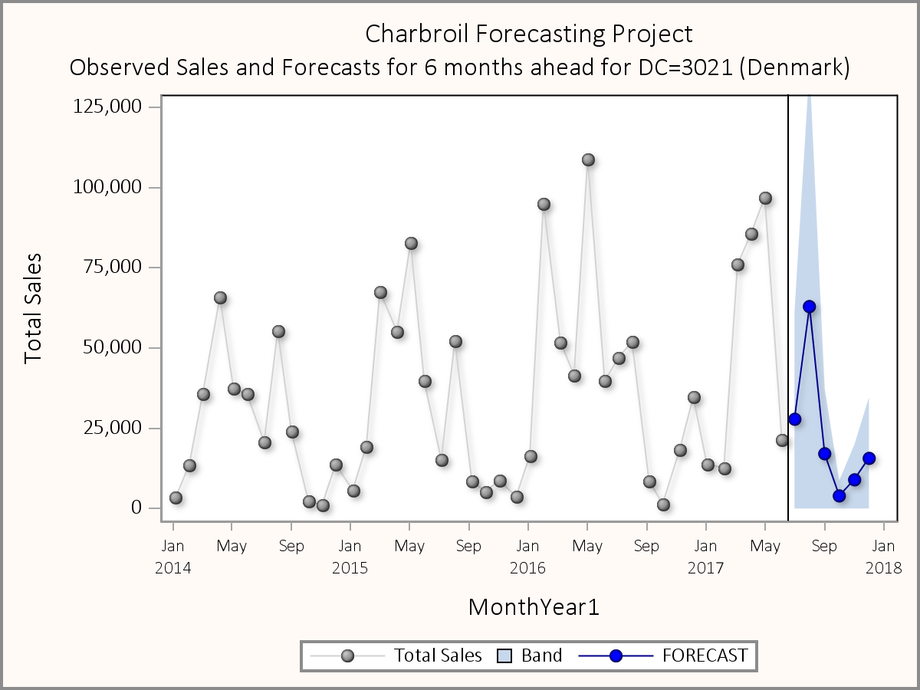

This is how we anticipate the time series to continue for 6 months beyond the observed data. The forecasts are in blue, with the confidence interval (aka confidence band).

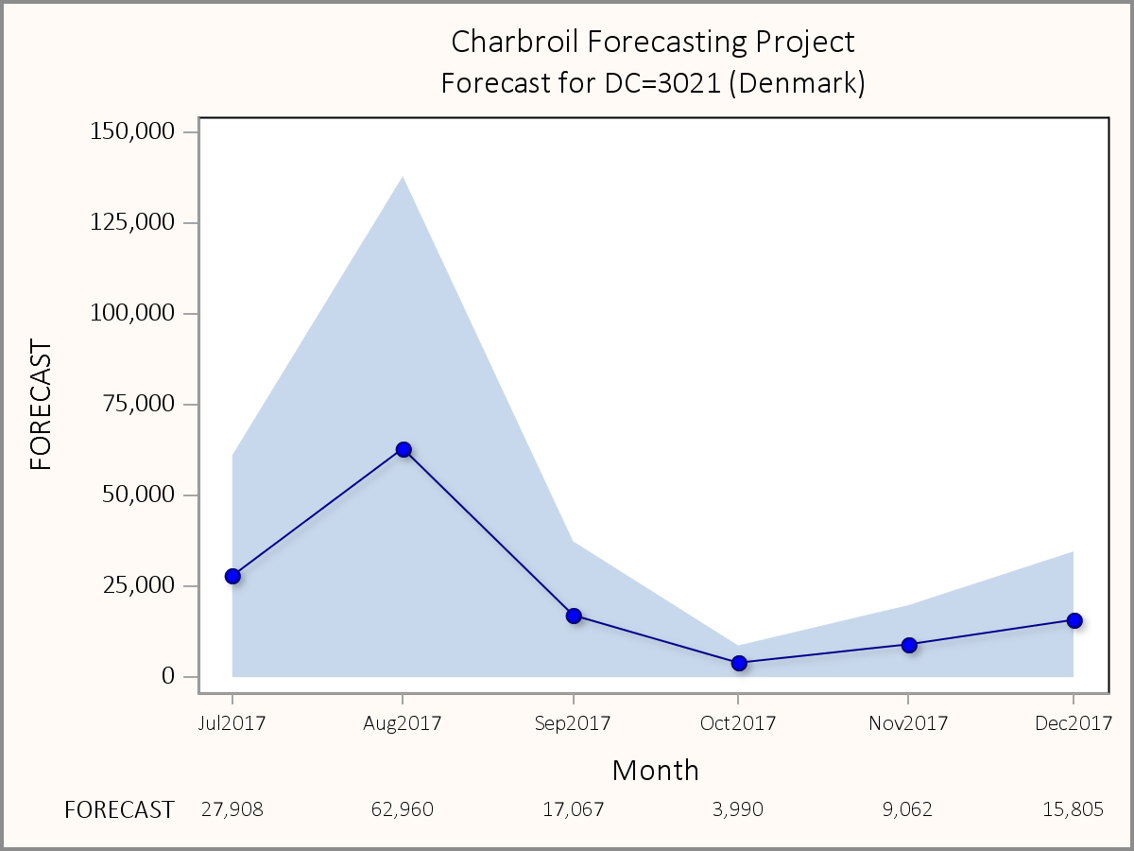

As we focus on the forecasting time period, we can see more closely the forecasted values for each of the 6 months.

Parameter | Value
WEIGHT1 | 0.016039
WEIGHT2 | 0.019155
WEIGHT3 | 0.222638
MAPE | 56.974622

These are our optimized values for the 3 parameters of the forecasting model. Respectively, they are Level (α: alpha), Trend (β: beta), and Season (γ: gamma). The resulting measure of forecasting error MAPE (Mean Absolute Percent Error) takes on this value of 56.97.

MonthYear | L95 | FORECAST | U95
JUL2017 | 0 | 27,908 | 61,141
AUG2017 | 0 | 62,960 | 137,941
SEP2017 | 0 | 17,067 | 37,395
OCT2017 | 0 | 3,990 | 8,744
NOV2017 | 0 | 9,062 | 19,859
DEC2017 | 0 | 15,805 | 34,638

The table above shows the forecasts, along with the 95% confidence interval (lower limit: L95, upper limit: U95).

